Blood Vessels of the Brain
- Anatomy of the Brain
- Blood Vessels of the Brain
- Atherosclerosis and Thrombus Formation
- Cerebral Embolism Formation
- Cellular Injury During Ischemia
- Additional Resources

Major Blood Vessels
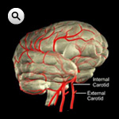
Click Image to Enlarge
Normal function of the brain’s control centers is dependent upon adequate supply of oxygen and nutrients through a dense network of blood vessels.
Blood is supplied to the brain, face, and scalp via two major sets of vessels: the right and left common carotid arteries and the right and left vertebral arteries.
The common carotid arteries have two divisions. The external carotid arteries supply the face and scalp with blood. The internal carotid arteries supply blood to the anterior three-fifths of cerebrum, except for parts of the temporal and occipital lobes. The vertebrobasilar arteries supply the posterior two-fifths of the cerebrum, part of the cerebellum, and the brain stem.
Any decrease in the flow of blood through one of the internal carotid arteries brings about some impairment in the function of the frontal lobes. This impairment may result in numbness, weakness, or paralysis on the side of the body opposite to the obstruction of the artery.
Occlusion of one of the vertebral arteries can cause many serious consequences, ranging from blindness to paralysis.
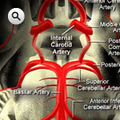
Click Image to Enlarge

Circle of Willis
At the base of the brain, the carotid and vertebrobasilar arteries form a circle of communicating arteries known as the Circle of Willis. From this circle, other arteries—the anterior cerebral artery (ACA), the middle cerebral artery (MCA), the posterior cerebral artery (PCA)—arise and travel to all parts of the brain. Posterior Inferior Cerebellar Arteries (PICA), which branch from the vertebral arteries, are not shown.
Because the carotid and vertebrobasilar arteries form a circle, if one of the main arteries is occluded, the distal smaller arteries that it supplies can receive blood from the other arteries (collateral circulation).
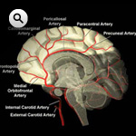
Click Image to Enlarge

Anterior Cerebral Artery
The anterior cerebral artery extends upward and forward from the internal carotid artery. It supplies the frontal lobes, the parts of the brain that control logical thought, personality, and voluntary movement, especially of the legs. Stroke in the anterior cerebral artery results in opposite leg weakness. If both anterior cerebral territories are affected, profound mental symptoms may result (akinetic mutism).

Middle Cerebral Artery
The middle cerebral artery is the largest branch of the internal carotid. The artery supplies a portion of the frontal lobe and the lateral surface of the temporal and parietal lobes, including the primary motor and sensory areas of the face, throat, hand and arm, and in the dominant hemisphere, the areas for speech.
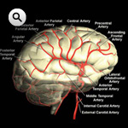
Click Image to Enlarge
The middle cerebral artery is the artery most often occluded in stroke.

Posterior Cerebral Artery
The posterior cerebral arteries stem in most individuals from the basilar artery but sometimes originate from the ipsilateral internal carotid artery [Garcia JH et al., In Barnett HJM at al (eds) Stroke Pathophysiology, Diagnosis, and Management New York Churchill Livingstone 1992 125]. The posterior arteries supply the temporal and occipital lobes of the left cerebral hemisphere and the right hemisphere. When infarction occurs in the territory of the posterior cerebral artery, it is usually secondary to embolism from lower segments of the vertebral basilar system or heart.
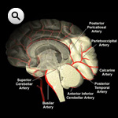
Click Image to Enlarge
Clinical symptoms associated with occlusion of the posterior cerebral artery depend on the location of the occlusion and may include thalamic syndrome, thalamic perforate syndrome, Weber’s syndrome, contralateral hemplegia, hemianopsia and a variety of other symptoms, including including color blindness, failure to see to-and-fro movements, verbal dyslexia, and hallucinations. The most common finding is occipital lobe infarction leading to an opposite visual field defect.

Lenticulostriate Arteries
Small, deep penetrating arteries known as the lenticulostriate arteries branch from the middle cerebral artery Occlusions of these vessels or penetrating branches of the Circle of Willis or vertebral or basilar arteries are referred to as lacunar strokes. About 20% of all stokes are lacunar [Stoke/Brain Attack reporter's Handbook. Englewood, Colo: National Stroke Association, 1995] and have a high incidence in patients with chronic hypertension.
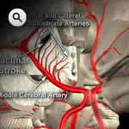
Click Image to Enlarge
In the elderly, CT scanning shows signs of infarction in only approximately half of the most of the common form of lacunar stroke (pure motor stroke), but MRI has increased the yield: the probability that CT or MRI will be positive is generally a function of the severity of the deficit [Mohr JP and Sacco RL, 1992]. The cells distal to the occlusion die, but since these areas are very small often only minor deficits are seen. When the infarction is critically located, however, more severe manifestations may develop, including paralysis and sensory loss.
Within a few months of the infarction, the necrotic brains cells are reabsorbed by macrophage activity, leaving a very small cavity referred to as a lake (or lacune in French).

